WORK BASED LEARNING FOR STUDENTS

Nataša Kristan Primšar¹, BSc in Chemistry; Srećko Simović², BSc in Electrotechnics; Tilka Sever³, BA in English and Slovene
¹ Šolski center Kranj, SLOVENIA, natasa.kristan@sckr.si
² Šolski center Kranj, SLOVENIA, srecko.simovic@sckr.si
³ Šolski center Kranj, SLOVENIA, sever.tilka@sckr.si

Abstract: Work based learning (WBL) is a very important part of high school education as it offers an opportunity for all the participants in the process. SC Kranj is very careful to provide good quality WBL and cooperation with industry. In order to make WBL as good as possible and to attract as many companies as possible to offer such learning, Slovenia has carried out some projects, such as Education of mentors and impetus for employers. SC Kranj is also involved in some international projects, such as SKILL4WORK (Erasmus+, KA2) to further promote WBL. The article also gives some examples of good practice.

Key words: work based learning, support for employers, international cooperation, examples of good practice

- INTRODUCTION

Work based learning is an important part of high school education as it helps students to develop general and specific competences in their field of study and consequently increases their job opportunities. It enables students to transfer their theoretical knowledge into practical work and they also have the opportunity to upgrade their theoretical knowledge gained in school and learn which skills are basic for their field of study. WBL gives them an insight into real working conditions and different tasks at work. At the same time WBL provides students with an opportunity for a later employment.
At SC Kranj would like all our students to spend WBL in optimum conditions therefore we try to attract as many companies and to educate as many mentors who help students in the companies as possible. We also wish to follow all international trends in the field of WBL. These goals are the reason for our active involvement in the projects that give support to employers in financial (impetus for employers) as well as educational field (education of mentors). At the same time we take part in international projects.
The outcome of all these activities are examples of good practice. Two of them, The replacement of Staircase Lighting in a Block of Flats and The Remodelling of a Petrol-driven Smart Car into an Electric Car, are presented at the end of the article.

- COURSE OF EVENTS AT SC KRANJ

The regulative basis for implementation of WBL for students is given in the 50th article of Post-Secondary Vocational Education Act which says that schools are obligated to cooperate with employers and can enter into contract for WBL implementation only with those companies that have suitable working places and equipment, engage in the same profession as the student is being educated for, and have an employee who can work as a mentor to the student.
The detailed conditions related to the place, equipment and mentors has been determined by Chamber of Commerce and Industry of Slovenia which also keeps a register of suitable employers.
The students have to spend 800 hours in WBL (400 hours during 1st year and 400 hours in 2nd year which means 10 weeks of WBL in each school year).
There is no difference between full-time and part-time students as regards WBL. It is obligatory for all part-time students who have not been employed for three years or their work experience does not correspond with their field of study.
Our students also have an opportunity to spend their WBL abroad as part of ERASMUS+ program.
WBL presents almost 50% of all credit points in the curriculum. It is supervised by the mentors in the chosen companies, mentors in the school and the organizer of WBL placement in the school. A successfully accomplished WBL is one of the requirements to enter 2nd year of education or a diploma exam.
The diploma paper presents the solution of a real-life problem that the students are faced with during WBL.

WBL comprises:
- The introductory part when a student gets to know the company (its activities and operations, its organization and the tasks of separate organizational units).
- The second part is meant for practical and individual execution of different tasks at the work place.
- The third part includes writing a Report on WBL (1st year students) and writing an Assignment and Report on the Accomplished Task (2nd year students)

  - The Procedure

    - The choice of companies and assignment of mentors in the companies
The students are free to choose the company for performing their WBL. If a student cannot find a suitable company, the organizer of WBL will help them. The students get a declaration for performing WBL from the company and submit it to the organizer of WBL.
    - The co-operation agreement signature
Co-operation Agreement is signed with every company by SC Kranj.
    - The three-part agreement about execution of WBL signature
The three-part agreement defines the inter-related obligations of the three partners, SC Kranj, the student and the company.
    - Implementation of WBL
The implementation of WBL follows the pre-arranged agenda, prepared by the mentor in agreement with the student. The program should be in accordance with the WBL catalogue which is determined by the curriculum. The student is expected to keep an operation log during WBL.
    - Conclusion of WBL
Having concluded the WBL the student can sit the final WBL exam and prepares all the necessary documents.
    - Report on WBL
On the basis of all reports and assessments, the organizer of WBL decides on the final mark and the number of credit points for WBL.

  - Co-operation with companies

The basic condition of a successful implementation of WBL is a good partnership between Vocational College and its partners, i.e. companies and enterprises. It should be based on trust, mutual assistance and responsibility of all participants. Everybody, the school as well as the students and the companies, should be aware of the importance of their co-operation. SC Kranj currently co-operates with more than 300 companies in the field of work based learning.
With a view to improve co-operation between the public sector and industry, Konektor Association, a partnership between the two, has been established. The signed agreement represents a commitment of all partners to co-operate in accomplishing these goals:
- development of new educational programs needed by the employers,
- customizing the education to the needs of employers,
- proactive co-operation in case of lack of suitable workers,
- eliminating the disparity between the current educational programs and the market demand,
- co-operation in mutual planning and execution of projects with a potential for the partners
- ensuring the continuity of the flow of knowledge between the industry and educational institutions.

There are about 200 students from seven different programmes sent from Vocational College to WBL per year:
- Economist,
- Electrical Engineering,
- Information technology,
- Mechatronics,
- Social network organizer,
- Administrative secretary,
- Security.

- SUPPORT FOR EMPLOYERS

Two incentives have been realized on the state level to encourage as many employers as possible for co-operation in WBL for students and its execution at the highest possible level:
  - Impetus for the employers,
  - Education of mentors.

  - Impetus for the employers

The goal of the call for tenders was to encourage the employers’ involvement in the work based learning in the curricula from 2008/09 to 2013/14.
The aim of the call of tenders was co-funding the execution of work based learning in suitably equipped work places for secondary vocational school students, and post-secondary vocational education students who have signed individual and collective educational contracts for work based learning. An active involvement of vocational and technical schools as institutions of education and organizers of work based learning was necessary to achieve that goal.
The object of the tender was the co-funding of payment for the mentor and a reward for the Secondary Vocational School students as well as Vocational College students. The costs are a result of the WBL activities of the employers for the benefit of the secondary and post-secondary school students. A part of the financial impetus was assigned also for the schools where the students were enrolled to help them implement the program. The financial means were assigned for direction, information and coordination of the employers as well as administrative-technical support for the preparation of all the necessary documents required for the application to the tender.
There have been seven tenders and the employers have received € 17,703,802.55 for their work based learning support. During all the school years, there have been 26,121 participants (secondary and post-secondary students) and 12,143 employers involved in the implementation of the work based learning.
Financial incentives for the employers from the European monetary funds are welcome and have encouraged a number of employers to offer work placement for students to sign a collective educational agreement. Unfortunately, the future of such incentives for the employers is uncertain. (Anica Justinek, CPI)

  - Education of mentors

There were two tenders for projects at state level to educate mentors for secondary and post-secondary school students in companies with a view to improve the quality of work based learning:
- 2012-2013 – »Education of mentors for work based teaching according to the curricula for acquiring qualification «
The expected result of the project was: 1800 qualified mentors in different companies.
There were three participating consortia. SC Kranj participated in one of them.
- 2016-2021 - » Education of mentors for work based teaching according to the curricula for acquiring qualification between 2016-2021«
The expected result of the project is: 5000 qualified mentors in different companies.
There are two participating consortia, one of which is managed by SC Kranj.
In both cases the education for mentors is free. They follow the prescribed programme and comprise at least 24 hours of lessons. The participants also receive a free brochure.

- PARTICIPATION IN DEVELOPMENT PROJECTS – SKILLS4WORK (ERASMUS+, KA2)

The partners involved in the project:
- H2 Learning, Ireland
- City of Dublin Education and Training Board (CDETB), Ireland
- Oberstufenzentrum Informations- und Medizintechnik (OSZ IMT) Germany
- CPI, Slovenia
- Šolski center Kranj, Slovenia
- South Eastern Regional College, Northern Ireland
The Project has provided a professional learning experience for all the project partners, as it has afforded them the opportunity to visit each country and to witness the many inter-connected elements of their WBL programmes. We have gathered their reflections on these visits in a project blog and we have collected a range of relevant documents that capture the processes and procedures each organisation has in place to manage WBL. These resources number more than 100 and can be found in the WBL Guidelines section.
The Project has been built around the concept of observing and capturing the WBL practices that exist in the partner organisations and using these as the basis for reflection. In addition to the WBL Guidelines we have also captured 4 case-studies, one per country which explore specific WBL examples in more detail. These case-studies can also be used to facilitate reflection and we have provided an example of how this might be carried out, using an example from Germany, Exploring Case Study 1 .
Project objectives were:
- To learn about existing work experience programmes in partner countries through practical study visits organised for VET teachers as part of the CPD strategy. To foster mutual learning between project partners.
- To set up a VET & Employers Working Groups in each partner country to collaborate together on developing and validating WBL implementation model and engaging in a dialogue on meaningful work experience practices.
- To develop WBL implementation guidelines for VET.
- To develop CPD materials for VET teachers.
- To extend employer participation in work-based learning practices across partner countries.
- To disseminate project outcomes across EU Member States.

- EXAMPLES OF GOOD PRACTICE

  - Replacement of old staircase lighting in a block of flats in Kranj

There are a lot several blocks of flats in the residential area Planina in Kranj, which were built 30 or more years ago. The staircase lighting in these blocks of flats is old-fashioned and energy-inefficient.
The goal of our project was to determine the positive effects in replacing the exisitng staircase lighting with a modern, energy-efficient one in one of the blocks of flats.
The whole project was set forth as a kind of co-operation of our educational institution with social partners and the local community. The participating partners were: some students of SC Kranj (Technical Secondary School – Power Engineering programme inside their module Electrical Wiring Planning), a student from Vocational College SC Kranj of Power Engineering, Zumbotel company from Ljubljana, Elektroservis Anton Maček s.p. from Škofja Loka and the owners of flats at Janeza Puharja 4 block of flats, who endorsed the idea of the project, signed the agreement for the project to be realized and also gave financial support for the replacement of the staircase lighting.
The goals of the project were:
- Carrying out the measurements of illumination and consumption of electricity for the current lighting.
- Utilising DIAlux program to sketch out four varieties of a new lighting system.
- Dismantling the existing lighting system and installing the chosen modern lighting system with a suitable sensor technology.
- Carrying the measurements of illumination and consumption of electricity of the new lighting system.
- Working out a comparative analysis of both sets of measurements and defining the economic viability of the project solution.
The block of flats is a nine storey building that was built in 1978. The staircase, corridors and the entrance to the building were illuminated by 115 incandenscent 40W bulbs. There were 109 lamps with one bulb and three lamps with two bulbs at the entrance to the block of flats.
It is important to mention that the whole system of staircase lighting was controlled by Iskra KO-31 contactor and an automatic switch produced by LEGRAND (type 047 02) which were located in the main switchboard cabinet in the basement of the building. The control was carried out by four sensors on each storey of the building.
The illumination measurements of the corridors and staircase were carried out by a calibrated luxmeter VOLTCRAFT LX-1108 (picture 2). The measurement points are shown in the floor plan of the ground floor in Picture 1.

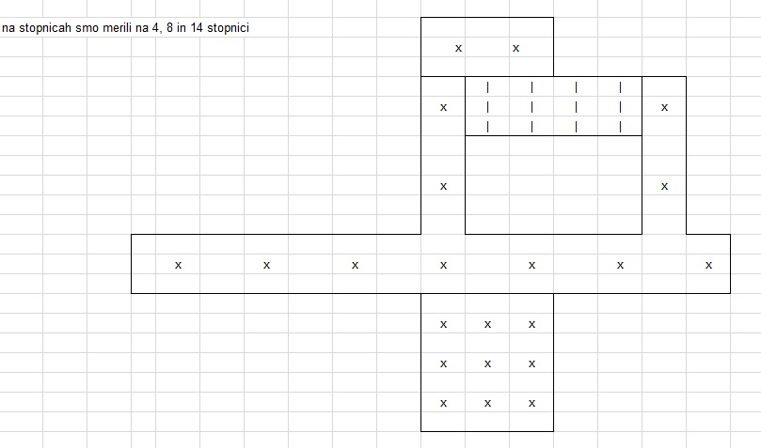
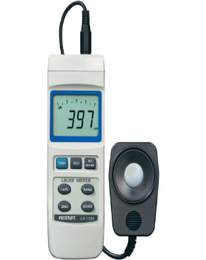
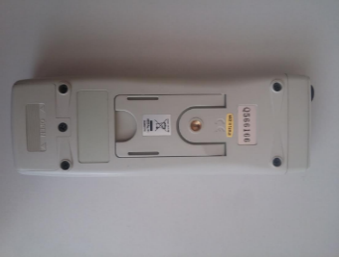

Picture 1: Measurement points – illumination measurement on the ground floor
Picture 2: Illumination measurement (Luxmeter VOLTCRAFT LX-1108)

The project of a new lighting system for the staircase in the building was carried out by utilising DIALux computer program. Four different complete varieties of lighting were sketched out as shown on Table 1.

Table 1: Calculations for 4 varieties of lamps
Lamp type | Power | Light flux | Light efficiency
Thorn Lighting PRISMA LED HF 4200 FR L840 | 39W | 4183 lm | 107 lm/W
Thorn Lighting FORCELED 4000 HF L840 | 40,5 W (42 W) | 4150 lm | 102 lm/W (98,8 lm/W)
ZUMTOBEL PERLUCE O 36W LED840 | 30 W | 2710 lm | 90 lm/W
Thorn Lighting NOVALINE 2000 LED HF E3 | 53 W | 2479 lm | 89 lm/W

Bearing in mind the lighting and technical characteristics as well as other factors, the chosen system was Thorn Lighting FORCELED 4000 HF L840. The light efficiency is 98.8 lm/W and the light flux 4150 lm. The level of mechanical protection is IP65 and is suitable for external use. The crucial factor for the choice was the lower price (approx. 40% less), which proved the right decision also from the point of view of the investors (the owners of the flats in this block of flats). It has to be said that the chosen lighting system does not much worse technical and lighting characteristics than the other three.
Dismantling the old system and installing the new one (Picture 3) was carried out by Elektro servis Maček Anton s.p. from Škofja Loka. The students of Power Engineering Programme of TSS SC Kranj played an active role in the activity. It is very important to stress that the replacement of the lighting system did not require any modifications of the existing electrical wiring in the building. After the lamps were connected to the mains, the sensor technology was set (movement sensor, level of illumination, range of operation). (Picture 4) The choice of the lighting system with integrated movement sensors and the possibility to set the lower limit of day light when the lights are switched on, and the combination of both, results in an increased energy-efficient lighting system.
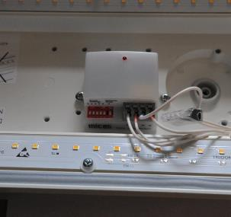
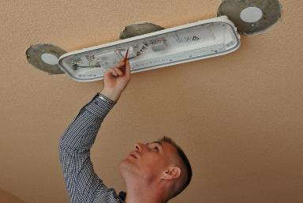

Picture 3: Installation of new lamps FORCELED 4000 HF L840 Picture 4: Setting the new sensors

The procedure for determining energy savings
The savings of energy for the staircase lighting in the building were determined on the basis of the measurements. The measurements of the old lighting system were carried out by a three-phase single-tariff electric meter SCHNEIDER ELECTRIC iEM31000 between 26th March 2015 and 26th April 2015 (31 days and 6 hours). There were 95 active incandescent lamps of 40W each, which means 3.8kW of total power.
The measurements showed that the average daily consumption of electricity for staircase lighting was about 9.3 kWh. In case all the lamps (115) had been active, the average daily consumption would have been about 11.25 kWh (Diagram 2). We cannot dismiss the fact that the exact data depends on various factors and could only be obtained by a more prolonged measurement, e.g. all year round. Nevertheless, our opinion is that the obtained data is useful for final evaluations and consequently conclusions about the average consumption of electricity for staircase lighting in the building in question.
Comparative values of the staircase and corridor current illumination (old) in the building and after the installation of the new system can be seen on Diagram 1.
Diagram 1: Illumination comparison

Diagram 2: Consumption of electricity for lighting

Conclusions:
- The recommended value of illumation 100 lx (SIST EN 12464) has been acquired.
- The illumination has risen by six to ten fold.
- The consumption of electrical energy has fallen by 3 fold.
- Less CO₂ emissions ().
- No additional rewiring.
- Seven years guarantee on installed equipment.
- The expected pay-off period for the financial input is a little more than five years.

The projects represents a model solution for similar remodelling of staircase lighting in blocks of flats as well as a very positive experience in co-operation among educational institution, social partners and the local community.

  - Remodelling a Smart petrol-driven passenger car into an electric car

The remodelling of a Smart petrol-driven car into an electric car, which will be homologized and used in public transport was a pilot project of Alpe Adria Green, An International Society for the Protection and Conservation of the Environment. The project was carried out at Makron Institute in Češnjica pri Kropi, owned by Andrej Pečjak, and was co-financed by the Slovenian EKO Foundation. The participants were 15 students from three technical secondary schools, namely Ljubljana, Škofja Loka and Kranj, and a student from Vocational College SC Kranj. The project was limited to one week in which everything had to be carried out. Practical work was combined with theoretical explanations and short lectures as well as all the necessary instructions for work in the workshop. The students were divided into three mixed groups. The whole idea of the project was for related technical schools to co-operate with social partners from the local community in a particular practical case. The goal was to make the idea of sustainable mobility appealing to young people. The students were able to compare an electric car with a traditional internal combustion vehicle, they learned about the problems with electric car batteries and made a battery for a Smart car, as well as learned about different charging stations, those with DC and AC technology. After a successful replacement of the engine, the students took a test drive. To make the car street worthy, the car had to be homologated, had to pass the technical inspection and be registered.
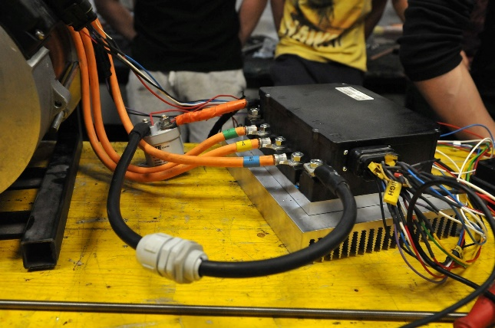
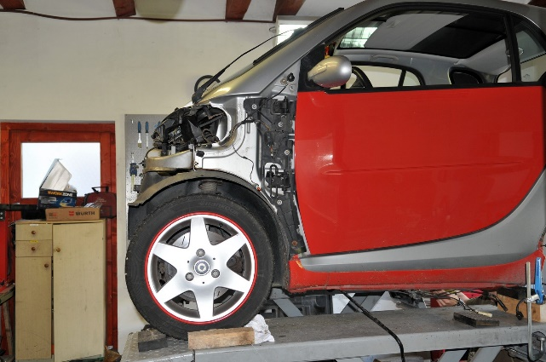
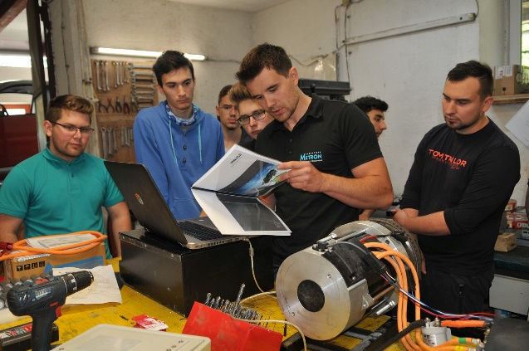
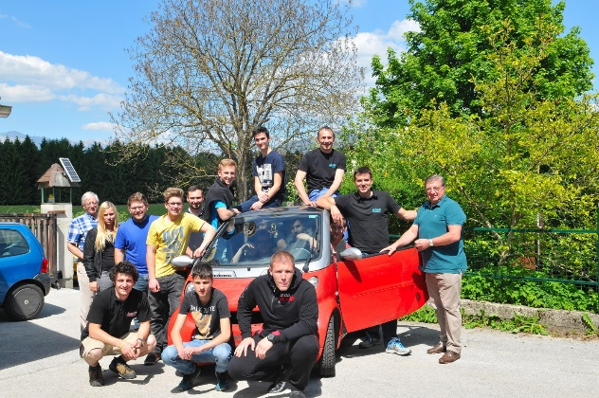

Pictures 5- 8: Remodelling a passenger internal combustion car into an electric car (Smart) (Photo: S. Simović)

- CONCLUSION

WBL in vocational education is very important. It is the basis for acquiring the competences needed for successful career. In the future WBL has to be developed in the way to improve cooperation between schools and economy. This is the opportunity to minimise so called “competence gap” and all the potentials of young generations will be developed.

REFERENCES
- ANICA JUSTINEK, HELENA ŽNIDARIČ, Usposabljanje mentorjev za praktično usposabljanje dijakov oziroma praktično izobraževanje študentov pri delodajalcu, Avaliable at http://www.cpi.si/izobrazevalni-programi/novi-in-prenovljeni-studijski-ter-izobrazevalni-programi/pedagosko-andragosko-usposabljanje.aspx [29. 8. 2017]
- KOHEZIJSKI E-KOTIČEK, 4-6. December, št.85, Avaliable at http://www.eu-skladi.si/sl/aktualno/e-novice/e-novice-december-2015.pdf Avaliable at [29. 8. 2017]
- http://skills4workproject.eu/ Avaliable at [29. 8. 2017]
- PODLIPNIK, P., ČOP A.: Svetlobnotehnični priročnik, Elektrokovina, Maribor, 1978.
- RAVNIKAR, I.: Električne inštalacije: učbenik za predmet elektrotehnika in električne inštalacije v 3. in 4. letniku programa elektrotehnik energetik, 3., predelana izd., 6. natis, Tehniška založba Slovenije, Ljubljana, 2007.
- DIALux, http://www.dial.de/DIAL/en/dialux.html [20. 9. 2015]
- THORN LIGHTING, Avaliable at http://www.thornlighting.com/en [20. 9. 2015]
- ZUMTOBEL, Avaliable at https://www.zumtobel.com/com-en/products.html [20. 9. 2015]
- ZUMTOBEL, The Lighting Handbook, Zumtobel, Dornbirn, AUSTRIA, 2013
- ZUMTOBEL ECOCALC, http://www.zumtobel.com/com-en/ecoCALC.html
- Stanivuković, D.: Diplomsko delo – Zamenjava stopniščne svetlobno-tehnične naprave v večnadstropni večstanovanjski zgradbi, Višja strokvna šola Šolski center Kranj, Kranj, 2015.

